CalendarMod documentation

# Introduction

This is the documentation for the software CalendarMod developed by [Nguyen Minh](https://nnminh171298.github.io/). This software is motivated by the “great” scheduler at Vaasa University of Applied Sciences (VAMK)

The software is used to automate the process of:

* Downloading the iCalendar (.ics) file from the page given by VAMK
* Modifying the calendar file (delete unuseful information)
* Clearing the primary Google calendar of the user (after being authorized)
* Inserting the modified events to Google calendar

This documentation assumes its users to:

* Have already download and unzip the folder containing the executable file (.exe) of the program

# How to use

## Obtain Google’s client ID

To use the program, the user has to first obtain a client ID from Google. The file enables Google to identify a registered project and give the program access to the enabled APIs. The fact that this program is a desktop application prevents the developer from sharing his client ID (containing secret key) for the user to use.

To obtain a client ID, one should visit [Google API Dashboard](https://console.developers.google.com/apis/dashboard) and create a project.

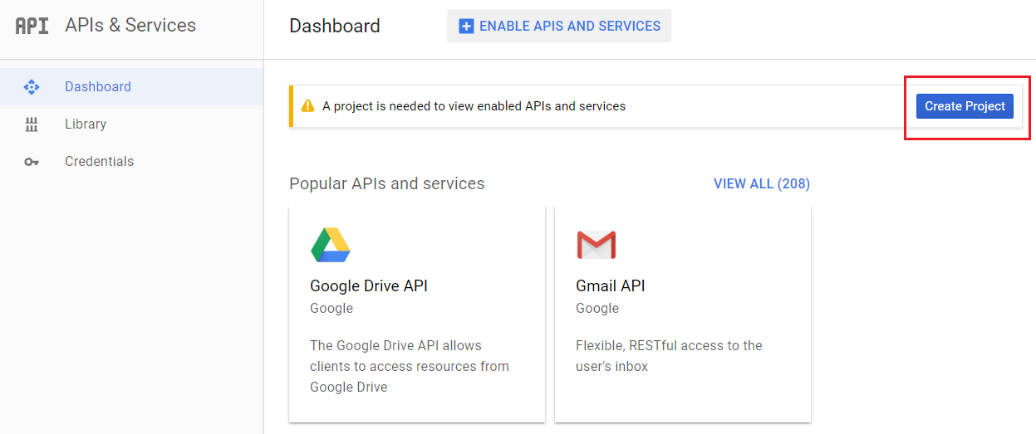

The recommended project name is “CalendarMod”. Then, choose “ENABLE APIS AND SERVICES”.

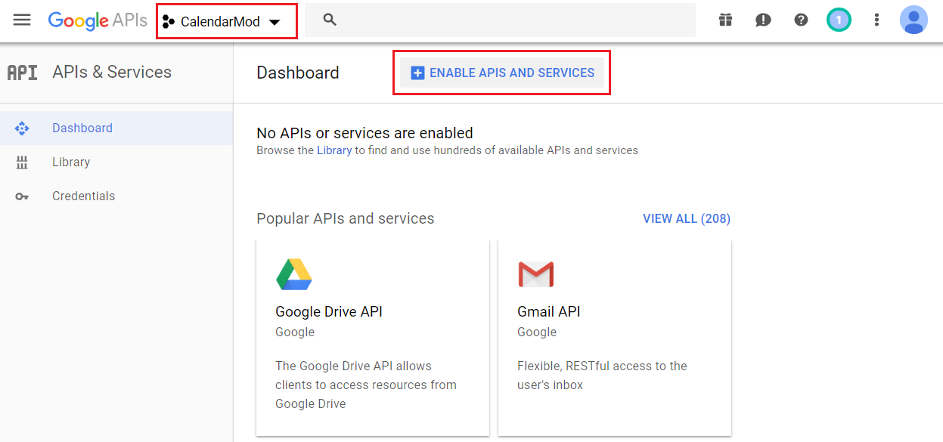

Search for “Calendar”, choose “Google Calendar API” and enable it.

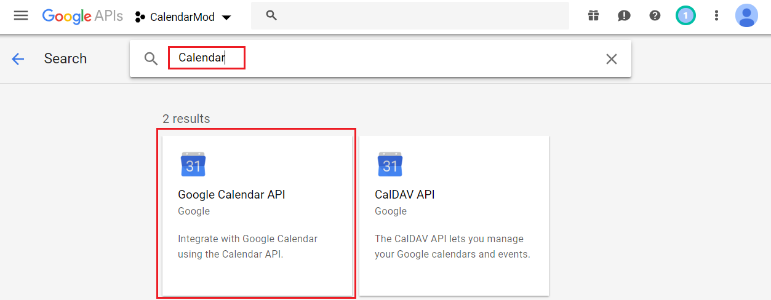

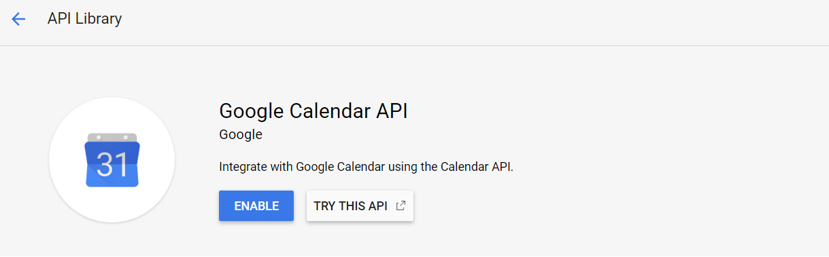

After about 10 seconds, the API should be enabled. However, to delete and insert events, Google also require authorization from the user. Therefore, the user has to create a credential.

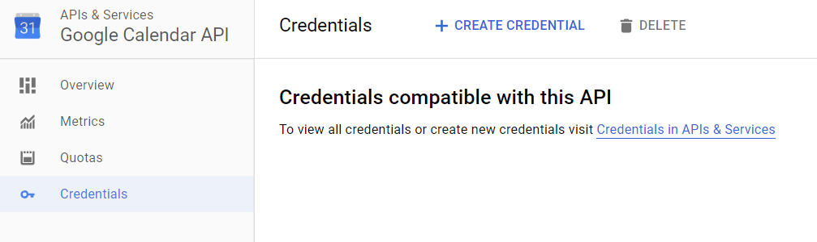

Follow the below figure when creating a credential

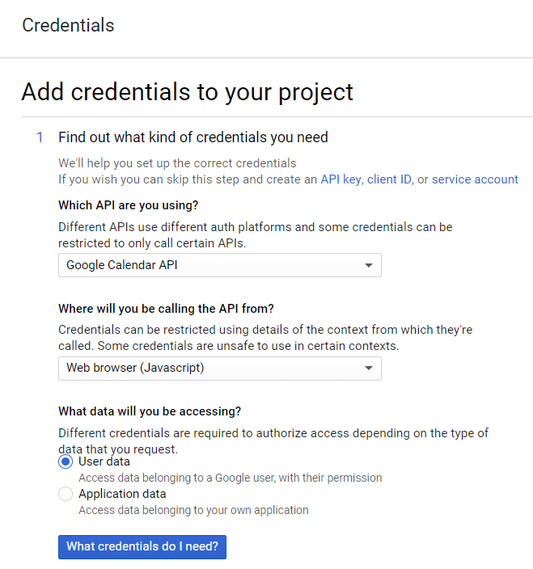 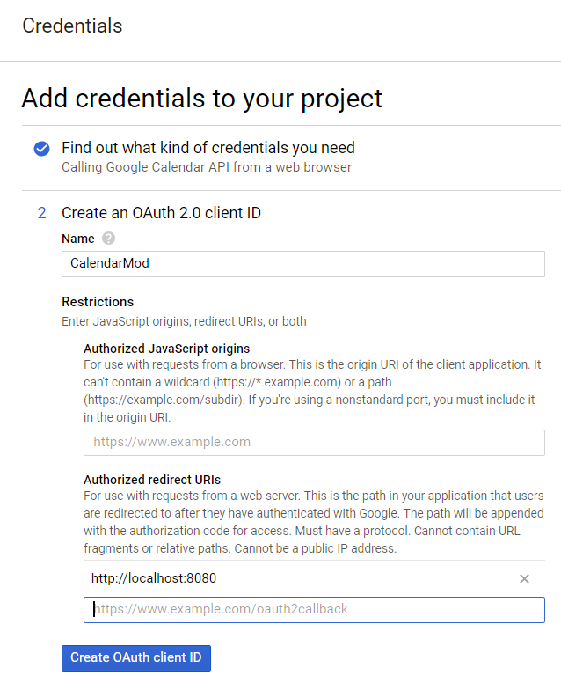

Fill in the fields with the values:

* Name: CalendarMod
* Authorized redirect URIs: http://localhost:8080/

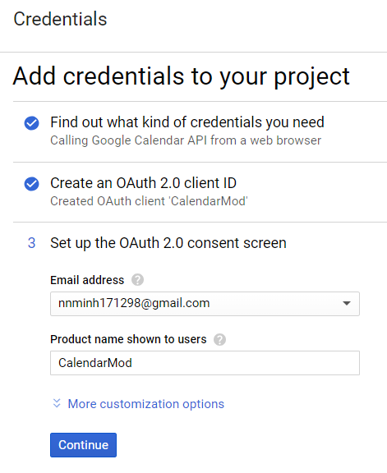 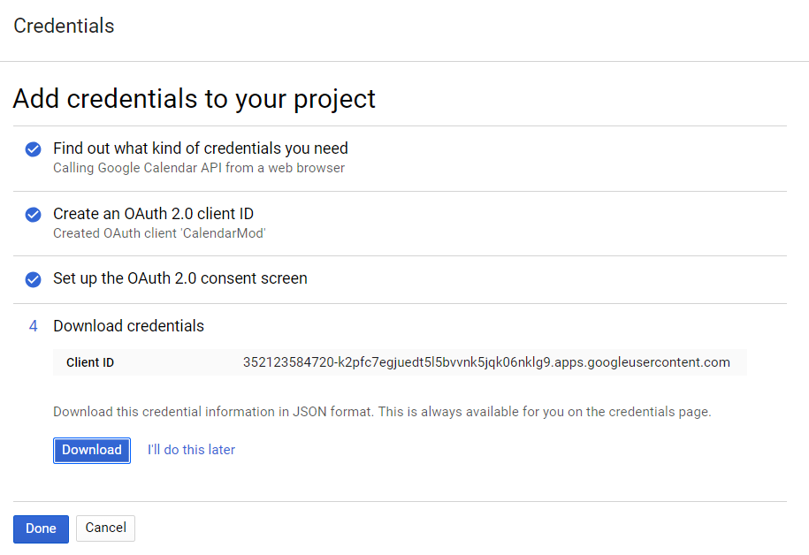

At the final step, choose “Download” and then choose “Done”. The file containing your client ID should be now downloaded under the name “client_id.json”.

Rename the file to “client_id_CalendarMod.json” and put it in the same folder with the executable file. The program is now ready to run.

## Using the program

Run the executable file. The program should display like the below figure.

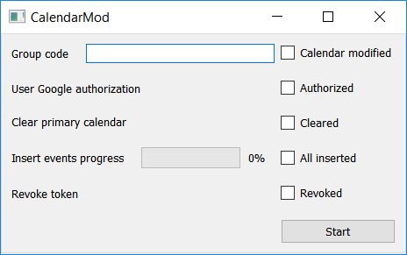

The user should enter the desired group code **IN PRINT** and click “Start”.

After modifying the calendar. Another window will show up asking for the user authorization.

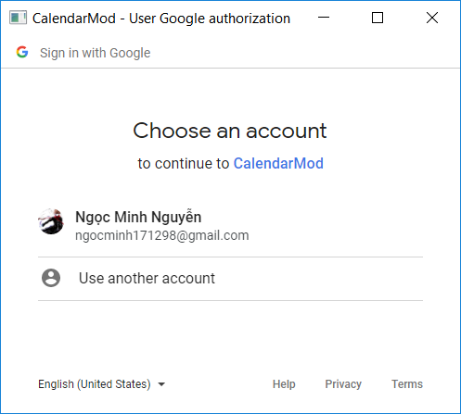 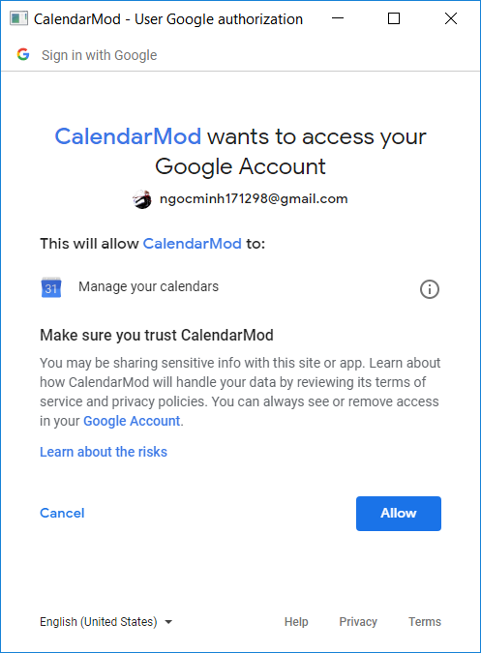

After that, the other tasks are completely automated. The user just has to wait until all the checkboxes are checked and the job is done.

# Result

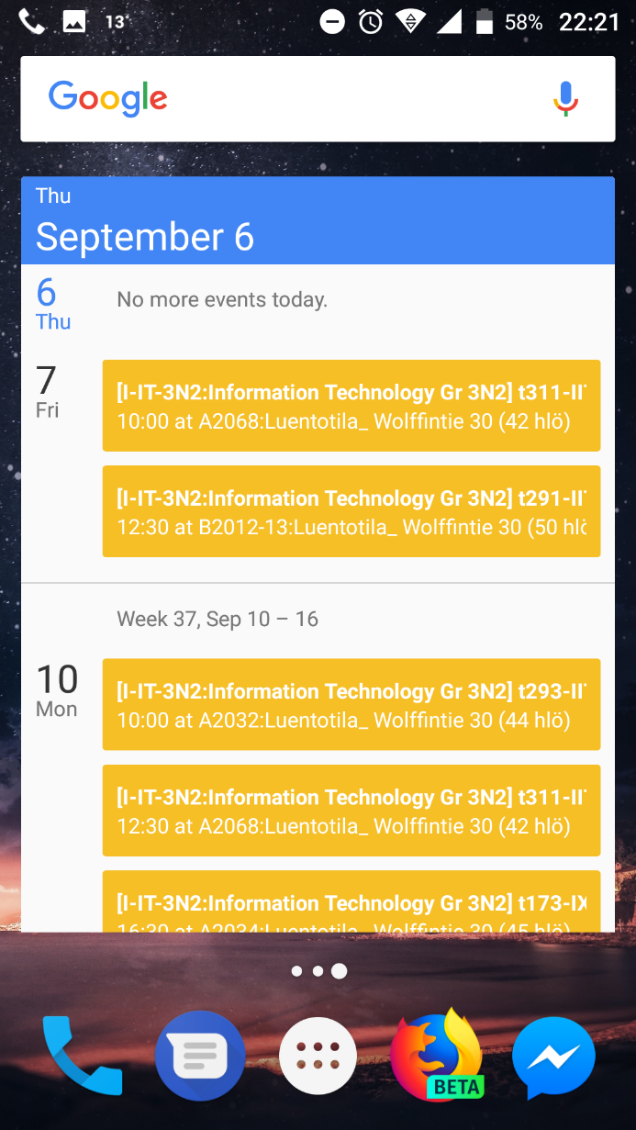 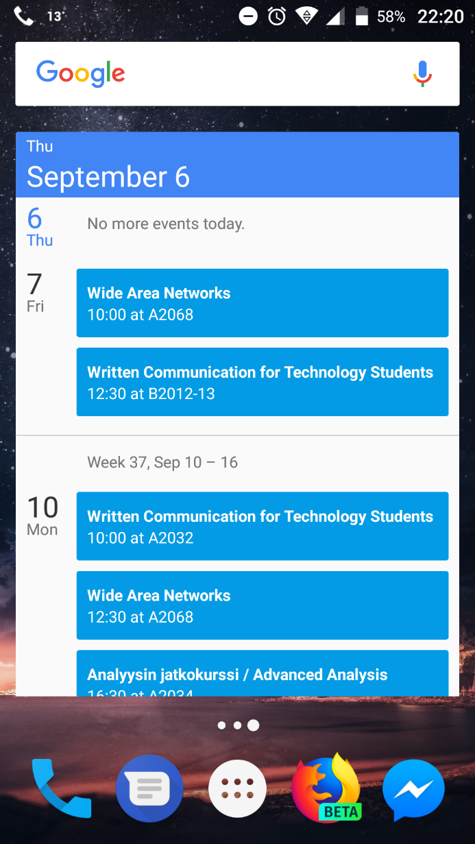

The left figure is how the calendar looks when added manually using the link given by VAMK without any modification

The right figure is how the calendar looks when added automatically using the program.